Literature review:
URL:
Jhoana P. Romero-Leiton, Alejandro Gutierrez, Ivan Felipe Benavides, Oscar E. Molina, and Alejandra Pulgarín, “An Approach to the modeling of honey bee colonies”, Published: 04 Mar 2022, https://we.copernicus.org/articles/22/7/2022/we-22-7-2022.html
Summary: The GLM (generalized linear modeling), a smooth model (mathematical approach) and a non-smooth (Filippov’s system theory) were considered in this research for the prediction of the reduction of honey due to a decrease in bee colonies. The modeling used stress factors such as habitat destruction, climate variability, season, neonicotinoids (pesticide) as inputs to the various models derived. The models evaluated the decrease in population of adult and immature honeybees over time along with the decrease of honey production. The GLM log-log model considered the production of honey as the response variable, the number of colonies as the prediction and year, latitude, area of each state and stress factors as covariates.¹ The document explains the use of various combinations of covariates using top-down stepwise modeling. The metrics used were AIC and root mean square error for performance evaluation. In the smooth mathematical approach, there were 3 equations that were formulated. One of the equations used was to model the variation of the number of immature bees at time t. It described the interaction among immature bees and adult bees at a given time along with the amount of honey produced. The assumption that immature bees grow at a rate of β proportionally to the number of adult bees was made.¹ The second equation represented the number of adult bees at time t. This equation considered the decrease of the number of adult bees using stress factors and natural causes. The third equation derived was the proportion of existing honey at time t. This equation depended on the production of honey in the hives which depended on the number of adult bees. It took into consideration the amount of honey consumed by the adult bees. Once these equations were formulated, they used algebraic equations to establish equilibrium points as a solution following the Jacobian matrix. The non-smooth model used Filippov’s system theory by providing death thresholds for the stress factors for both minimum value of stress factor allowed, and the maximum stress factor allowed. The equations are then determining the stress factor where the adult bees establish equilibrium between the min and the max.
The modeling performed in this mathematical modeling contained various assumptions on the correlations of the increase and/or decrease in number of adult bees and the amount of honey available for some of the equations presented. For the GLM modeling, data from the USDA that contains the data for colony abundance and honey production was used to make the predictions. They emphasized that the total number of bees within the colony can decrease due to external stress factors, which could be climate, pesticides, parasites. The additional factors were done using simulations and numerical experiments. Our project will consider various features such as temperature, air quality, diseases, and pesticides using real historical time series data made available to feed into regression models to forecast the number of bee colonies. The modeling can be trained, validated, and tested for its accuracy in its capability to forecast using optimization of the model’s parameters to minimize errors. It will also consider the various state in the United States.

Jun Chen , Gloria DeGrandi-Hoffman, Vardayani Ratti , Yun Kang, “Review on mathematical modeling of honeybee population dynamics”, Published: Nov. 4, 2021, https://www.aimspress.com/article/doi/10.3934/mbe.2021471?viewType=HTML
The mathematical equations to model the bee population considering the factors that include temperature, rainfall, light, distance of quality of food, and the effects on colony growth and survival. The various equations were broken into various categories as follows:
- Honeybee parasites and/or virus interactions modeling
- Honeybee only models with age and/or food/nutrient components modeling
- Effects from pesticides modeling
- Computation models modeling
Each of these mathematical models proposed different formulations of mathematical equations for the recruitment and loss rates of colony members in terms of density dependent social components. The first model for honeybee parasite/virus, explained that 20 viruses infect honeybees. This model derived equations on how the impact of parasites cause a decrease in the number of bee colonies. The mathematical model developed assumes infections spread horizontally with additional mortality with infected honeybees. The equations considered the natural death number, the infectious effect and death rate due to disease. The mathematical equation accounted for the change in number of adult bees due to the new worker bees with cooperative effects – mortality rate of cooperative effects (cooperative effects include the honeybee population, rate of daily egg-laying by the queen, colony size). Another model formulated was the interactive of food and population dynamics in honeybee colonies. This model suggested food availability and forager death rate influences colony growth and development.² The pesticide modeling used a honeybee difference equation model tracking the foragers leaving and entering the hive each day to study impact of pesticide that causes homing failure. The mathematical equations formulated considered daily production of new uncontaminated foragers and daily contaminated foragers considering the mortality rate. This document did recommend that the use of machine learning for validation of the theoretical models since it is lacking in the mathematical models presented. Model validation with experimental data is needed to provide confidence in model predictions.² Our project will consider what this document has recommended regarding the use of machine learning modeling to validate information. Our project will use regression models to validate, and test using real historical time series data with various factors that can impact the number of bee colonies to predict and forecast. Our project will use regression models that use optimization to reduce errors to provide accuracy in the forecast of the number of bee colonies for the various states in the United States.
Two paragraph summary of LSTM methodology:
A time series modeling is considered a sequence-to-sequence prediction model to forecast the future response based on historical data. With the use of real data collected for this project consisting of a time series with multiple features, modeling can be used to identify correlations with various features that impact the outcome of the number of bee colonies for each state in the US. One type of modeling considered for this project is the LSTM (long short-term memory) recurrent neural network. The model can be trained with historical data, validated, and tested to forecast the number of bee colonies in the future using various dependent features. In addition, it offers the capability to optimize internally using the gradient descent for each of its parameters and equations using the loss function of mean squared error to obtain the best fit model and obtain better results. Trends, and seasonality will impact the results for a time series, and they can be detected prior to the model and ensure a stationary time series.
LSTM (Long Short-Term memory) is a recurrent neural network that depends on the input sequence (order of observations) that is important for prediction. It processes the information (data) sequentially passing on information as it propagates forward in the neural network. The LSTM network can learn a mapping function for the inputs over time to an output. The internal memory can condition the output on the recent context in the input sequence along with the previous state.¹ It offers the capability to learn long term correlations in a sequence and can be modeled by multiple parallel input series separately with varied length of input sequence to produce a variable length of output sequence.¹ LSTM can remember information for longer periods of time (resolving the issue of short-term memory with recurrent neural networks) and it resolves the back propagation problem of the gradient vanishing when assigning weights to the neural networks. LSTM uses gates and cell states which are capable of learning long-term dependencies to regulate the flow of information. The cells make decisions on how much, when to store and release information to make accurate predictions.
Architecture of the LSTM network
The LSTM architecture consists of a set of recurrently connected memory cells (referred as memory block cell). Each memory cell consists of four layers where three are referred to the gates and the fourth is the cell state. The cell state allows only relevant information to flow to the connected memory cells in sequence which can be considered as the long-term memory of the network.² Cell state carries all the information along all the time steps. The gates are to help regulate the information flow in the memory cell to identify which information is important to keep and discards information that is irrelevant. As a result, with the use of gates and cell state LSTM is capable of learning long-term dependencies to regulate the flow of information.⁸ The previous data information (neural networks memory referred to hidden state which can be referred as short term memory)² and the new information are formed as vectors and is processed one at a time passing through the cell state (memory that holds information from the hidden state) to the next step in sequence. As a result, previous information can be carried all the way to the end of the chain. “The hidden state accesses the neural networks memory holding information on previous data information that the network has seen before.”⁶
The internal memory cell consists of three gates (forget, input, output gate) and the cell state. Figure 1.
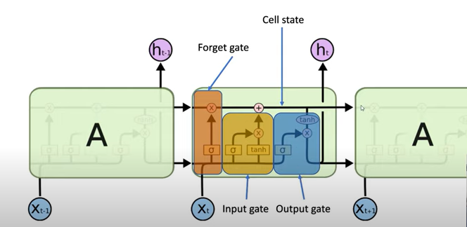
Figure 1
The first step is to identify the relevant information from the cell state, C_{t-1,} by taking the previous time step information learned in the hidden state (h_{t-1}) and the new input (x_{t}) to form a vector and determine which bits go through the cell using the sigmoid function (returns a value of 0 or 1) for each cell state, C_{t}. If the cell state is 1, it is information that needs to stay; otherwise, it is discarded. The result is the f_{t} value. Please refer to forget gate in figure 2 and figure 2a for the equation.³
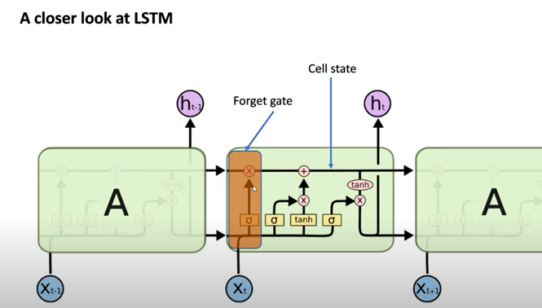
Figure 2
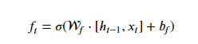
Figure 2a
Input gate will calculate temporary memory activation vector with new values, C̃_{t}, for the cell state to control the new temporary memory cell information for the current state, refer to Figure 3 and 3a. The i_{t} is the sigmoid applied on the previous hidden state and current input to identify the values of importance as 1 and irrelevant to 0. In addition, pass the hidden values and current input into the tanh function. Tanh is used to eliminate the vanishing gradients issue recurrent neural networks has. Gradients are used to update the neural network weights and shrinks to 0 when it back propagates through time (please refer to Gradient descent in LSTM for more information). Without the tanh, there would be 0 weights in the neural network and the cells would no longer contribute to the learning process.
Tanh also regulates the values between -1 and 1 since the second derivative can sustain long range before it becomes 0 or too large to assign weights. Please refer to figure 3 and 3a.³
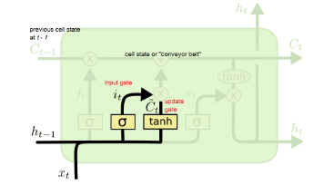
Figure 3
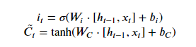
Figure 3a
The old cell state, C_{t-1}, is updated into the new cell state C_{t}. First multiply the tanh output to the sigmoid output (i_{t}) for sigmoid to decide which information is relevant for the tanh output. The old state is multiplied by f_{t}, which eliminates the information decided to forget in the cell state, then add i_{t}*C̃_{t} (the new values on the amount scaled decided to update at each state value), Figure 4³. The memory cell state is updated which will enable the LSTM memory cell to remember information over long periods.
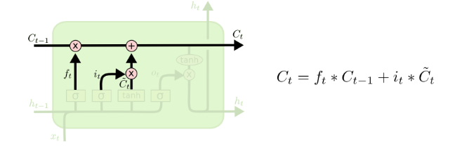
Figure 4
Information is then processed to the output gate to decide what the next hidden state should be. Output gate takes the hidden state and current input into the sigmoid function then pass the modified cell state to the tanh function. Both the tanh and sigmoid output are multiplied to decide which information the hidden state should carry the output. The new cell state which contains the long-term memory of the network and new hidden state which contains the short term memory of the current memory cell are carried to the next time step. Figure 5.³
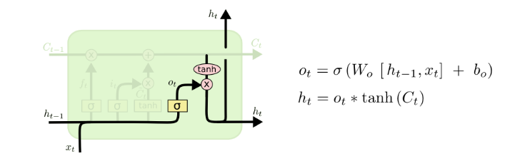
Figure 5
From the equations for each gate operation, the data goes through various transformations in order to determine how relevant it is to the input.
Gradient Descent and optimized parameters in LSTM
Neural networks use back propagation (propagates error back from output nodes to input nodes) to train and fine tune the weights based on the error rate obtained from a previous epoch. This ensures lower error rates to make a model reliable.⁵ The optimization function used is the gradient descent to determine the parameters that produces minimal loss for the next iteration. As a result, the gradient to update the various parameters to optimize the output is taken with using the loss function with respect to the various parameters. In our project, the loss function that will be used is the mean squared error since it is a regression analysis using time series data.
The following is the equation for the mean squared error in LSTM⁴:
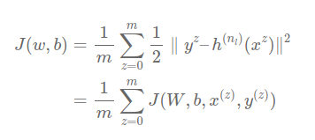
Figure 6, mean squared error of the loss function in LSTM from all the components for all data points
Where J(W, b, x^{(z)}, y^{(z)}) is the following:⁴
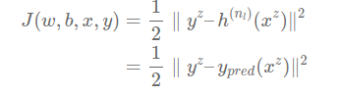
Figure 7, the mean squared error of the loss function used for LSTM regression for each data point⁴
w are the weights, b is the bias, x is the input as a vector, y is the output value.

The gradient descent is using the following equation to update the weights:⁷

W_{new} = W_{old} – learning rate * gradient with respect to parameter using loss function
As a result, the following is the gradient descent for the various parameters.
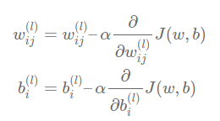
Figure 8, gradient descent equation to update weights and bias⁴
The following will be variables to distinguish the parameters for each of the equations in each of the layers in the memory cell for LSTM as well as the derivation of the gradient descent for each of the parameters.⁶
- W_{f}, b_{f} – forget gate weight and bias
- W_{i}, b_{i} – input gate weight and bias
- W_{c}, b_{c} – new update cell state weight and bias
- W_{o}, b_{o} – output get weight and bias
- a_{f}, a_{i,} a_{c,} a_{o} – input activation functions to sigmoid
- f_{t}, i_{t}, c̃_{t}, c_{t}, o_{t} – output of the activation functions
- J – cost function
- Z_{t} – [h_{t-1},x_{t}] vector
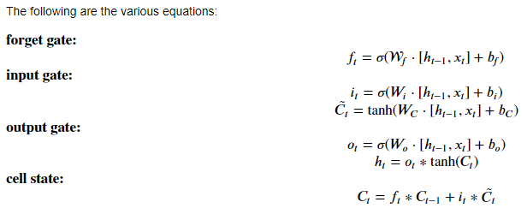
Figure 9, various equations for the three gates and cell state of the LSTM memory cell
where h_{t-1} is the historical information in the hidden state, x_{t} is the new input, [h_{t-1}, x_{t}] is a vector.
To simplify the derivations of the gradient descent set the following equations:⁶
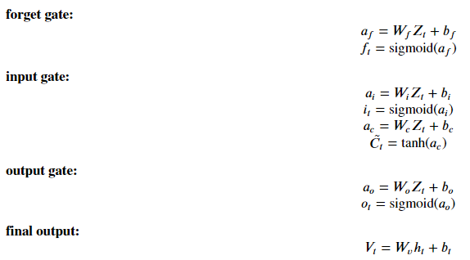
Figure 10, use of variables to define the activation function for each gate including the final output linear equation⁶
Please note that when the derivative of the sigmoid is taken, the following is true:
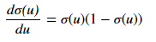
As a result, for some of the gates that have a sigmoid applied, for example forget and input gate, the derivative above will be used to substitute of ơ(u) = linear function of the gate.
Gradient of hidden state with final output
Using the final output equation, where h_{t} is the current time stamp given some current weights, using the loss function, the following is the gradient with respect to hidden state, h_{t}, the weights and biases using the loss function
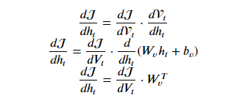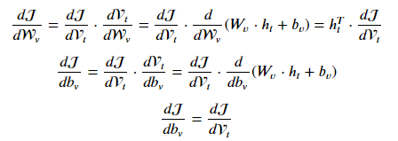
Figure 11, left: gradient of hidden state, right: gradient of weights and bias⁶

Gradient of output gate
The following is the sequence of steps for the output gate to the loss function, o_{t} $→$h_{t}$→$V_{t}$→$J. As a result, the back propagation is o_{t} $←$h_{t}$←$V_{t}$←$J (recall that V_{t} is the final output which is part of the loss function). Using the loss function, taking the derivative with respect to o_{t} for the output gate, the weights and bias, the following is the derivation:
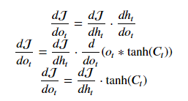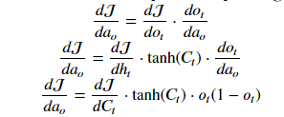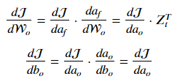
Figure 12, left: gradient of output gate, middle: gradient of activation function for output gate, right: gradient of weights and biases⁶

Gradient of cell state
Recall that the cell state is the one that controls the information flow within the memory cell from input to output. As a result, the path that the cell state is C_{t}$→$h_{t}$→$V_{t} $→$J. Using the loss function, taking the derivative with respect to C_{t} for the cell state, the weights and bias, the following is the derivation and the derivation for the previous cell state:
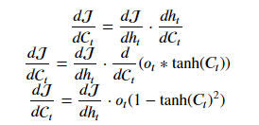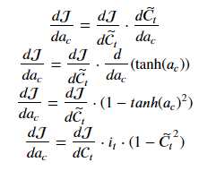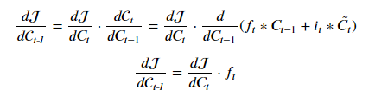
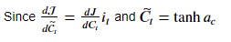
Figure 13, left: gradient of current cell state, middle: gradient of activation function for cell state, right: gradient of the previous cell state⁶

Gradient of input gate
The sequence for the data information to pass through the input gate is as follows i_{t}$→$C_{t}$→$h_{t}$→$J. The back propagation is the reverse, i_{t}$←$C_{t}$←$h_{t}$←$J. As a result, the various gradients using the loss function are as follows
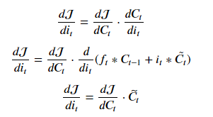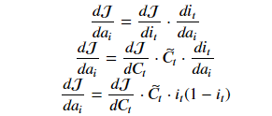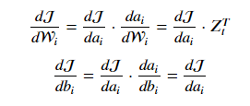
Figure 14, left: gradient of the input gate, middle: gradient of the activation function for input gate, right: gradient of weights and biases⁶
As part of the input, the cell state needs to be updated with the new current cell state values. Therefore, the gradient for the new cell state
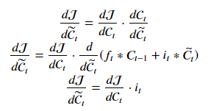
Figure 15, gradient of the new cell state⁶
Gradient of forget gate
When the data goes through the LSTM memory cell, it moves from f_{t} $→$C_{t}$→$h_{t}$→$J. Back propagation reverses. As a result, the sequence is backwards f_{t} $←$C_{t}$←$h_{t}$←$J. The various gradients using the loss function are as follows

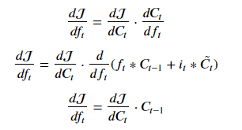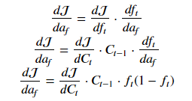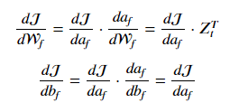
Figure 16, left: gradient of the forget gate, middle: gradient of the activation function for forget gate, right: gradient of weights and biases⁶
Gradient of vector Z_{t}
The vector containing the previous hidden state and the current input, is input to the forget gate, input gate, cell state and output gate. As a result, the gradient for each of the Z_{t} values used follow the derivation below:
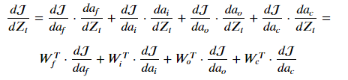
Figure 17, gradient descent of the vector Z_{t} = [h_{t-1},x_{t}]⁶

The derivation was with respect to one sequence of the process that occurs in LSTM. As a result, each memory cell would have to be accounted corresponding to the number of data points in the time series.
Resources:
- Brownlee, Jason, Long Short-Term Memory Networks with Python (Jason Brownlee, 2017), 229.
- Dolphin, Rian, “LSTM Networks | A Detailed Explanation”, Towards Data Science, Last modified Oct. 21, 2020, https://towardsdatascience.com/lstm-networks-a-detailed-explanation-8fae6aefc7f9
- DigitalSreeni, “An introduction to RNN and LSTM”, youtub.com, Last modified 2 years ago, https://www.youtube.com/watch?v=Mdp5pAKNNW4&t=54s
- Cheng, Tiffany, “Neural Network Math, LSTM Background”, hackmd.io, Last modified 5 months ago, https://hackmd.io/@tiffanycheng/Sy9ondrv5,
- Al-Masri, “How does Back-Propagation in Artificial Neural Networks Work?”, towardsdatascience.com, Last Modified Jan. 29, 2019, https://towardsdatascience.com/how-does-back-propagation-in-artificial-neural-networks-work-c7cad873ea7
- Rahuljha, “LSTM Gradients”, towardsdatascience.com, Last Modified Jun 29, 2020, https://towardsdatascience.com/lstm-gradients-b3996e6a0296
- Phi, Michael, “Illustrated Guide to LSTM’s and GRU’s: A step by step explanation, towardsdatascience.com, Last modified Sep 24, 2018, https://towardsdatascience.com/illustrated-guide-to-lstms-and-gru-s-a-step-by-step-explanation-44e9eb85bf21
- https://colah.github.io/posts/2015-08-Understanding-LSTMs/
Preprocessing of AirQuality data:
The air quality time series data will be used as features to identify the correlation between the features and the outcome of the bee colonies. The data was downloaded from the United States Environmental Protection Agency (EPA) using the pre-generated data from the website at https://aqs.epa.gov/aqsweb/airdata/download_files.html. The Annual Summary Data per county was extracted for the years of 1987 to 2022 since the bee colony information was only available for this year range. The data was preprocessed using python to merge all the various years data sets into one file. The data was grouped into states and counties to obtain the aggregate mean using the county values for each state for each of the feature columns. This allowed to obtain the mean values for each of the state. The data was cleaned to only obtain the 50 states in the US. In addition, created a column for a mapping of the full state name to the abbreviated form in case other data sets had this type of naming convention.

